DAY 11
File Handling
File handling in Java refers to the process of reading from and writing to files on a computer's file system. Java provides various classes and methods to perform file operations, such as creating, reading, writing, and deleting files.

Key Concepts:

- File Input/Output Streams: Java uses streams to read from and write to files. Input streams are used to read data from a file, while output streams are used to write data to a file.
- File Classes: Java provides several classes for file handling, including File, FileInputStream, FileOutputStream, FileReader, and FileWriter.

Common File Operations:

- Creating a File: You can create a new file using the File class and the createNewFile() method.
- Reading from a File: You can read from a file using FileInputStream, FileReader, or other reader classes.
- Writing to a File: You can write to a file using FileOutputStream, FileWriter, or other writer classes.
- Deleting a File: You can delete a file using the File class and the delete() method.

Java File Handling Classes:

- *File Class:* Represents a file or directory and provides methods for file operations.
- *FileInputStream Class:* Used to read data from a file.
- *FileOutputStream Class:* Used to write data to a file.
- *FileReader Class:* Used to read characters from a file.
- *FileWriter Class:* Used to write characters to a file.

TASK 001:
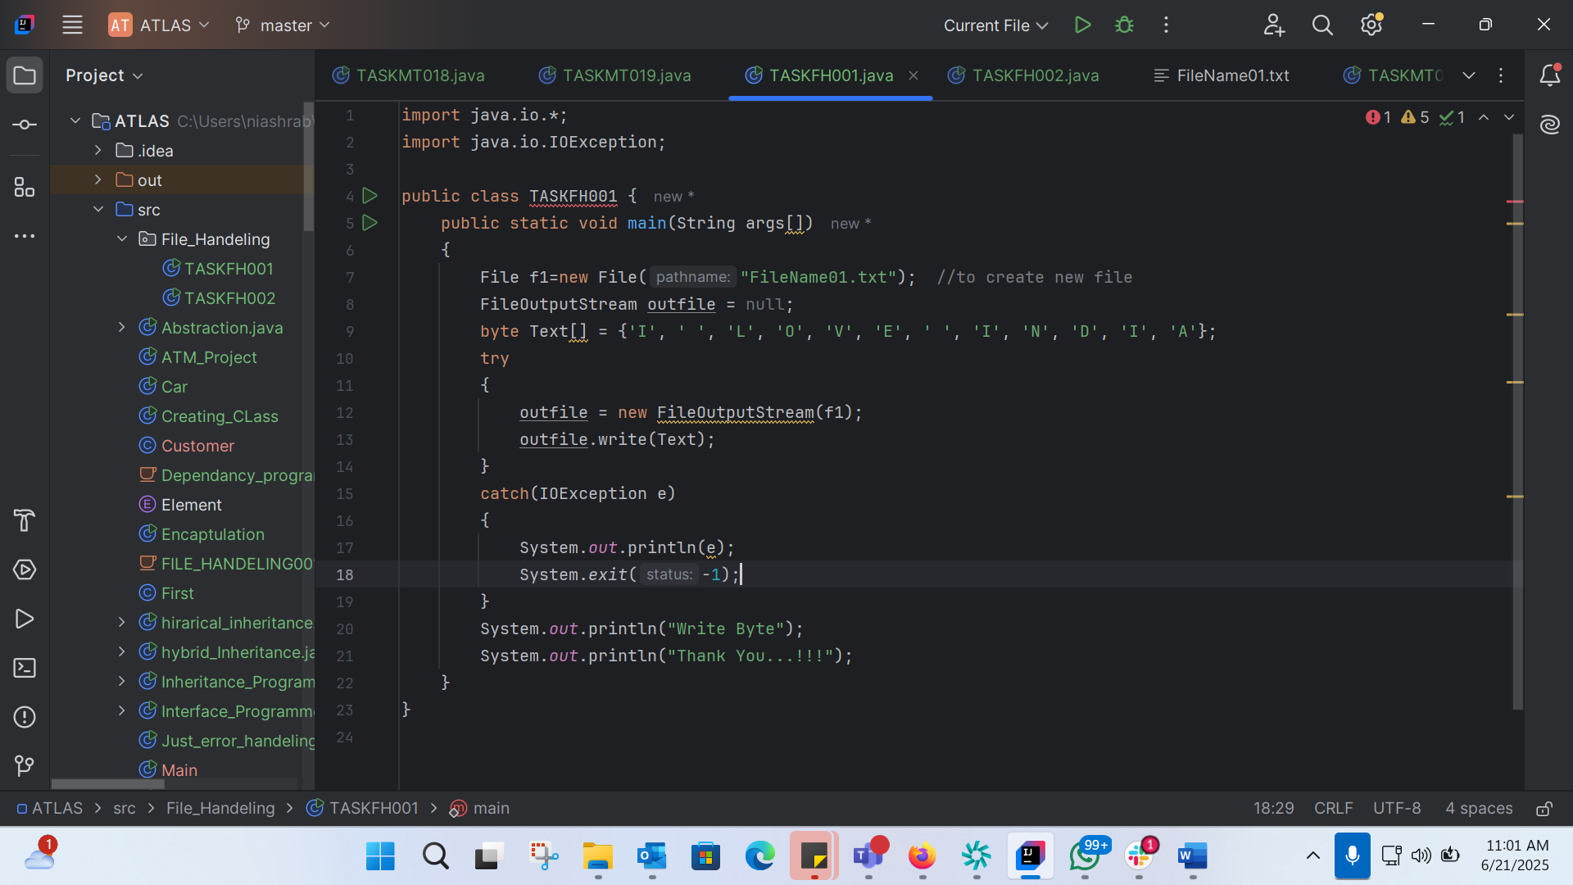
import java.io.*;
import java.io.IOException;
public class TASKFH001 {
public static void main(String args[])
{
File f1=new File("FileName01.txt"); //to create new file
FileOutputStream outfile = null;
byte Text[] = {'I', ' ', 'L', 'O', 'V', 'E', ' ', 'I', 'N', 'D', 'I', 'A'};
try
{
outfile = new FileOutputStream(f1);
outfile.write(Text);
}
catch(IOException e)
{
System.out.println(e);
System.exit(-1);
}
System.out.println("Write Byte");
System.out.println("Thank You...!!!");
}
}

TASK002:
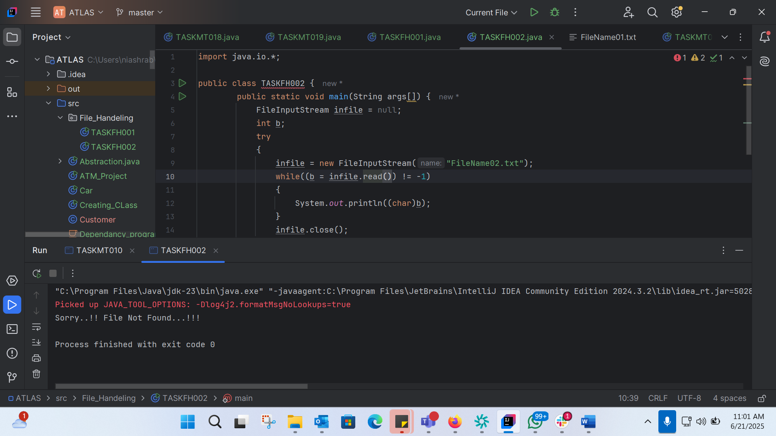
import java.io.*;
public class TASKFH002 {
public static void main(String args[]) {
FileInputStream infile = null;
int b;
try
{
infile = new FileInputStream("FileName02.txt");
while((b = infile.read()) != -1)
{
System.out.println((char)b);
}
infile.close();
}
catch(IOException e)
{
System.out.println("Sorry..!! File Not Found...!!!");
}
}
}

TASK 6:
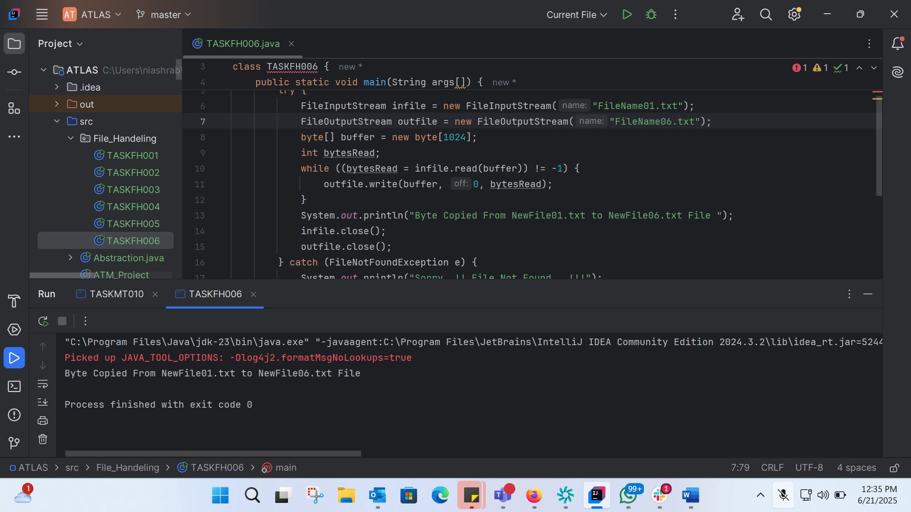
import java.io.*;
class TASKFH006 {
public static void main(String args[]) {
try {
FileInputStream infile = new FileInputStream("FileName01.txt");
FileOutputStream outfile = new FileOutputStream("FileName06.txt");
byte[] buffer = new byte[1024];
int bytesRead;
while ((bytesRead = infile.read(buffer)) != -1) {
outfile.write(buffer, 0, bytesRead);
}
System.out.println("Byte Copied From NewFile01.txt to NewFile06.txt File ");
infile.close();
outfile.close();
} catch (FileNotFoundException e) {
System.out.println("Sorry..!! File Not Found...!!!");
} catch (IOException e) {
System.out.println(e.getMessage());
}
}
}

Task7:
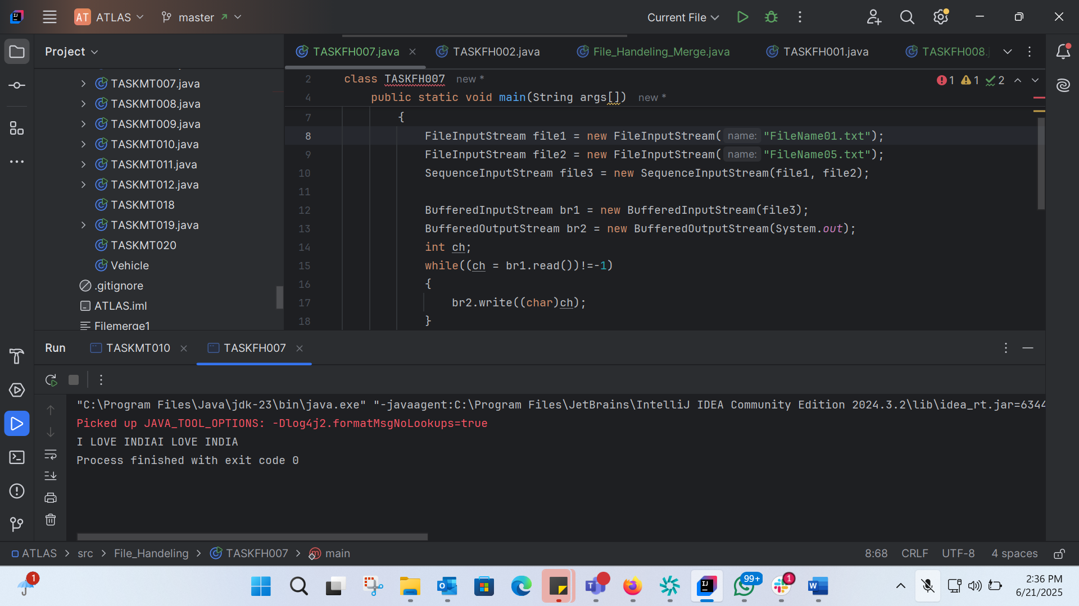
import java.io.*;
class TASKFH007
{
public static void main(String args[])
{
try
{
FileInputStream file1 = new FileInputStream("FileName01.txt");
FileInputStream file2 = new FileInputStream("FileName05.txt");
SequenceInputStream file3 = new SequenceInputStream(file1, file2);
BufferedInputStream br1 = new BufferedInputStream(file3);
BufferedOutputStream br2 = new BufferedOutputStream(System.out);
int ch;
while((ch = br1.read())!=-1)
{
br2.write((char)ch);
}
br1.close();
br2.close();
file1.close();
file2.close();
System.out.println("Merge Two File Sucessfully ");
}
catch(IOException e)
{
System.out.println("Sorry..!! File Not Found...!!!");
}
}
}

Task 8:
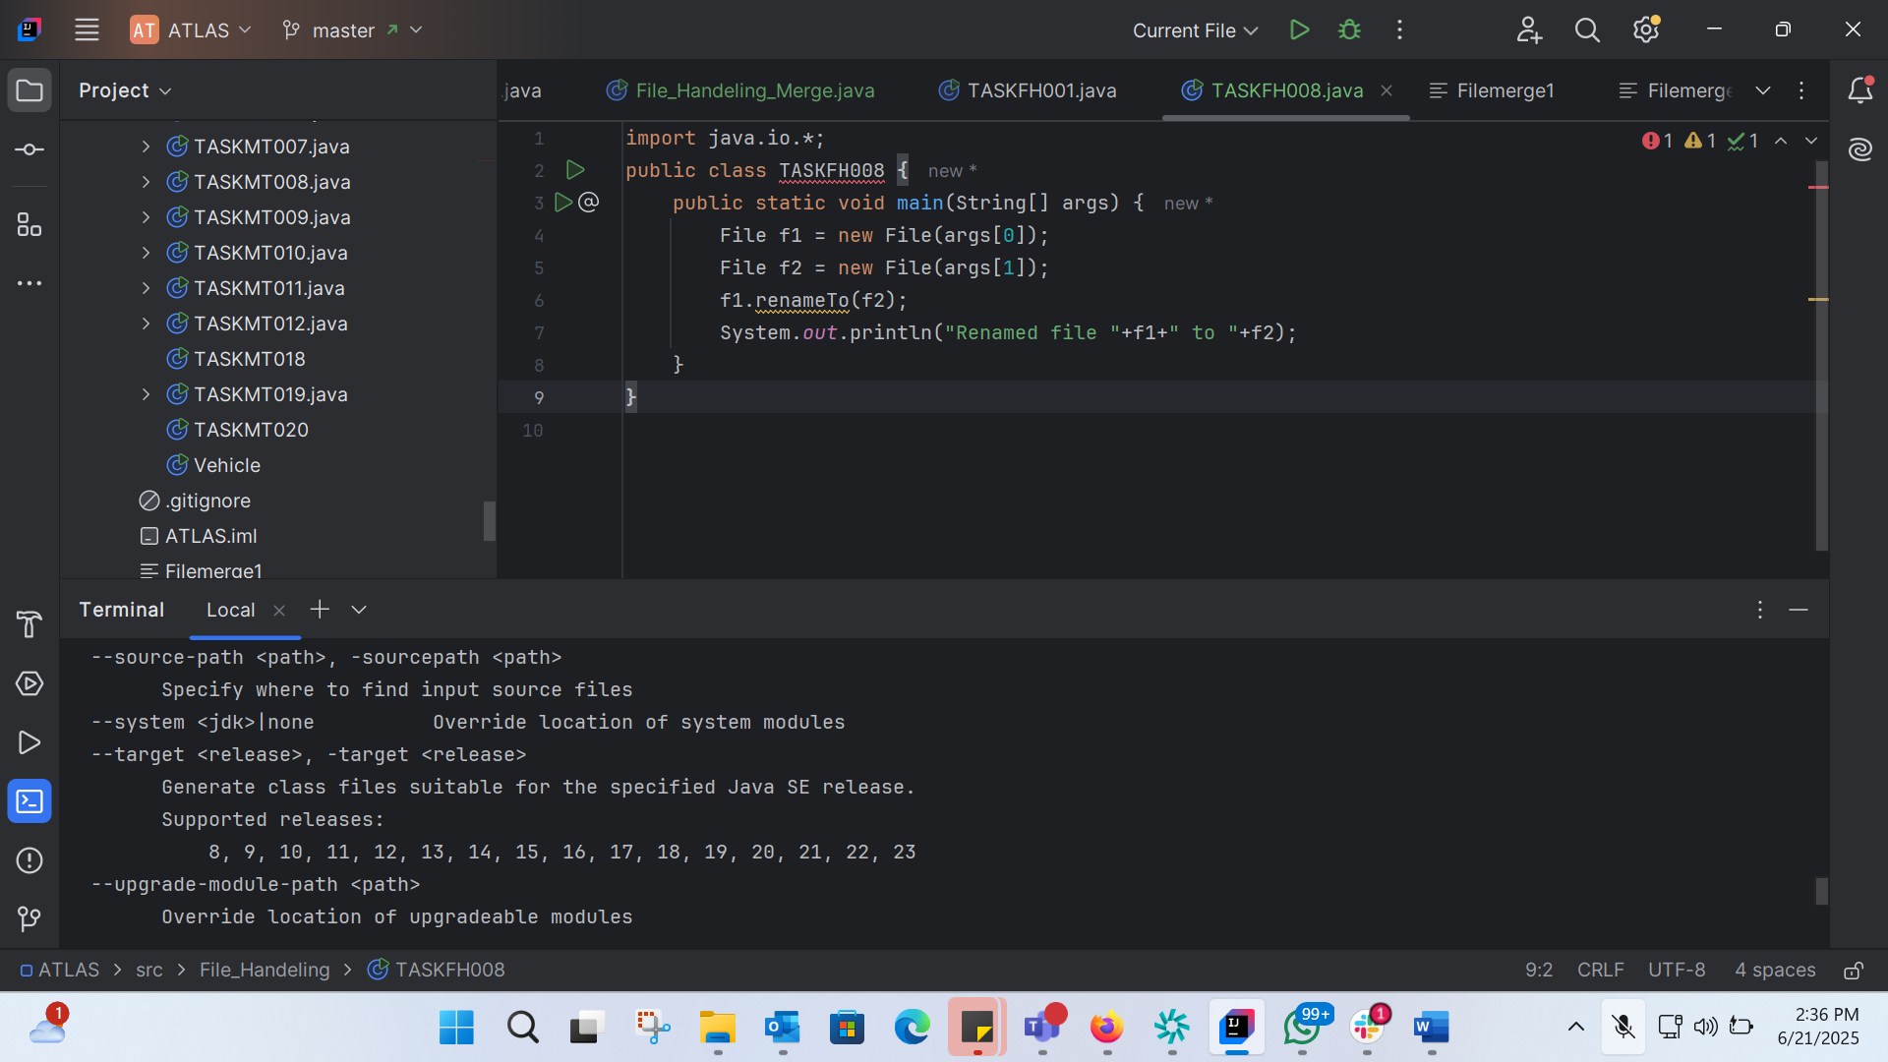
import java.io.*;
public class TASKFH008 {
public static void main(String[] args) {
File f1 = new File(args[0]);
File f2 = new File(args[1]);
f1.renameTo(f2);
System.out.println("Renamed file "+f1+" to "+f2);
}
}

BIOLER PLATE CODE:
Boilerplate code refers to a section of code that is repeated in multiple places with little to no variation. It is often used to describe code that is necessary for a particular task or functionality, but does not provide any unique or interesting logic.
TASK 9:
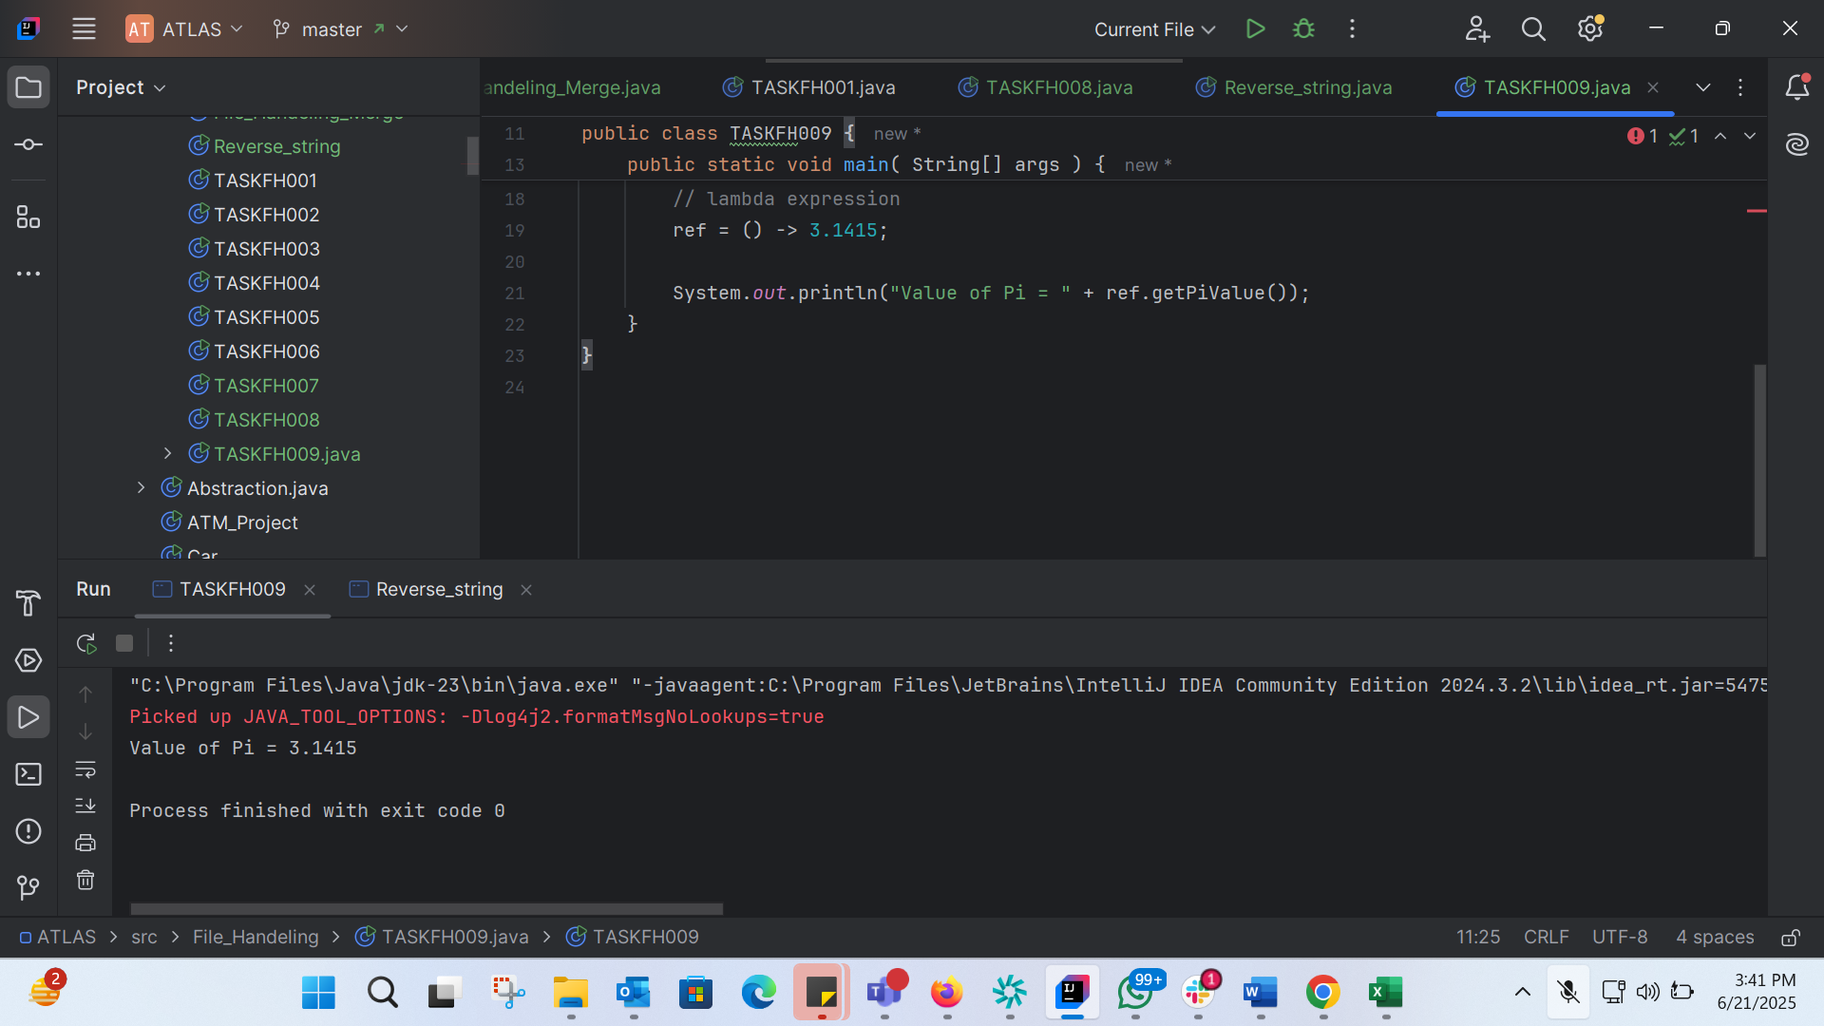
import java.lang.FunctionalInterface;
// this is functional interface
@FunctionalInterface
interface MyInterface{
// abstract method
double getPiValue();
}
public class TASKFH009 {
public static void main( String[] args ) {
// declare a reference to MyInterface
MyInterface ref;
// lambda expression
ref = () -> 3.1415;
System.out.println("Value of Pi = " + ref.getPiValue());
}
}
TASK 10: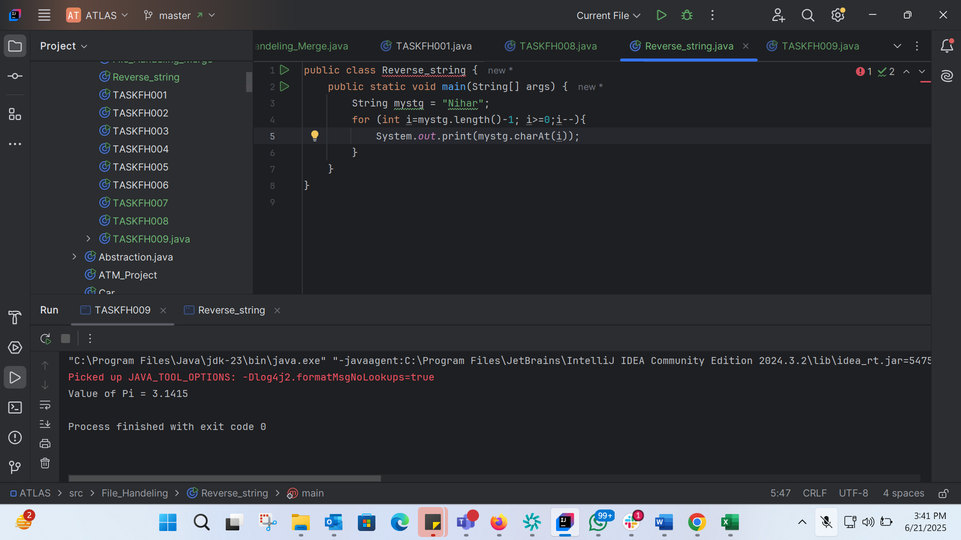
public class Reverse_string {
public static void main(String[] args) {
String mystg = "Nihar";
for (int i=mystg.length()-1; i>=0;i--){
System.out.print(mystg.charAt(i));
}
}
}

TASK 11:
@FunctionalInterface
interface Myinterface {
// abstract method
String reverse(String n);
}
public class TASKFH011 {
public static void main( String[] args ) {
// declare a reference to MyInterface
// assign a lambda expression to the reference
Myinterface ref = (str) -> {
String result = "";
for (int i = str.length()-1; i >= 0 ; i--)
result += str.charAt(i);
return result;
};
// call the method of the interface
System.out.println("Lambda reversed = " + ref.reverse("Lambda"));
}
}

Task 12:
public class TASKFH012 {
public static void main(String[] args) {
String[] friends = {"Nihar", "Faizal", "Ashraf","Fathima", "Marzia"};
for (int i= 0; i<=friends.length-1; i++){
System.out.print(friends[i]+" ");
}
}
}

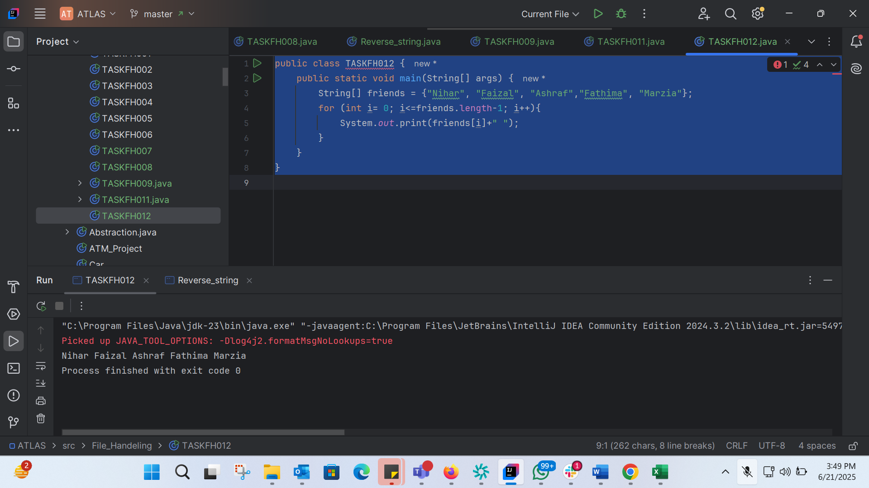
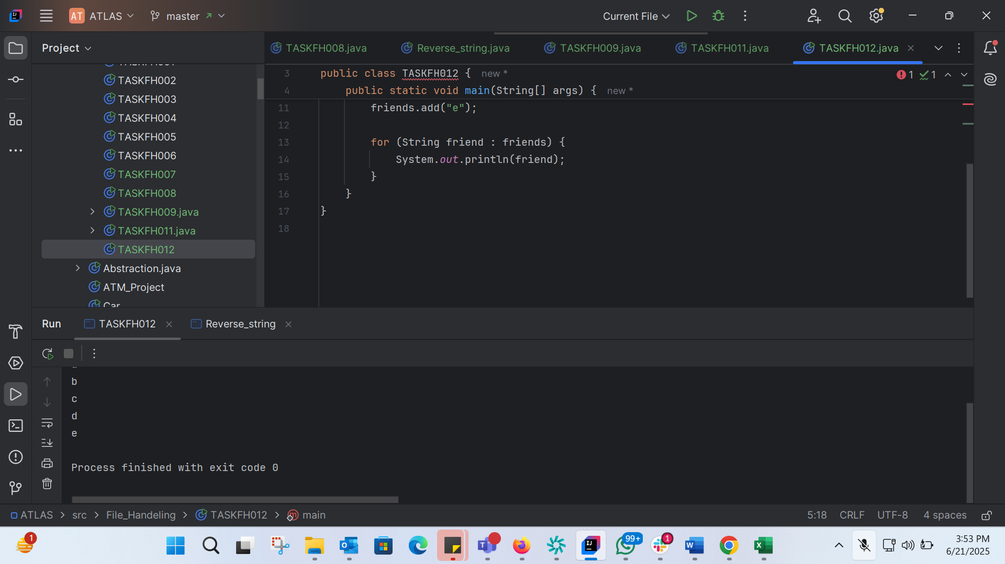
import java.util.ArrayList;
public class TASKFH012 {
public static void main(String[] args) {
ArrayList<String> friends = new ArrayList<>();
friends.add("a");
friends.add("b");
friends.add("c");
friends.add("d");
friends.add("e");
for (String friend : friends) {
System.out.println(friend);
}
}
}

Task 13: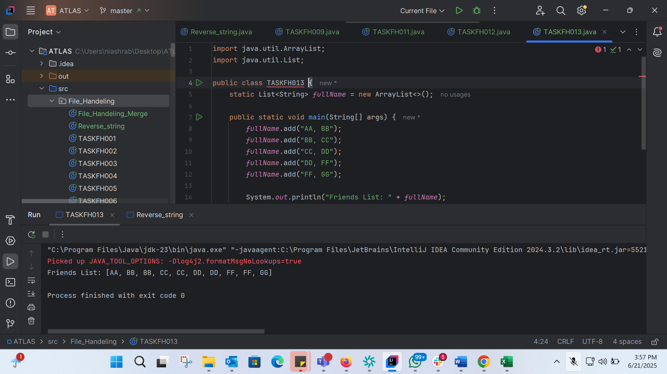
import java.util.ArrayList;
import java.util.List;
public class TASKFH013 {
static List<String> fullName = new ArrayList<>();
public static void main(String[] args) {
fullName.add("AA, BB");
fullName.add("BB, CC");
fullName.add("CC, DD");
fullName.add("DD, FF");
fullName.add("FF, GG");
System.out.println("Friends List: " + fullName);
}
}

TASK 14: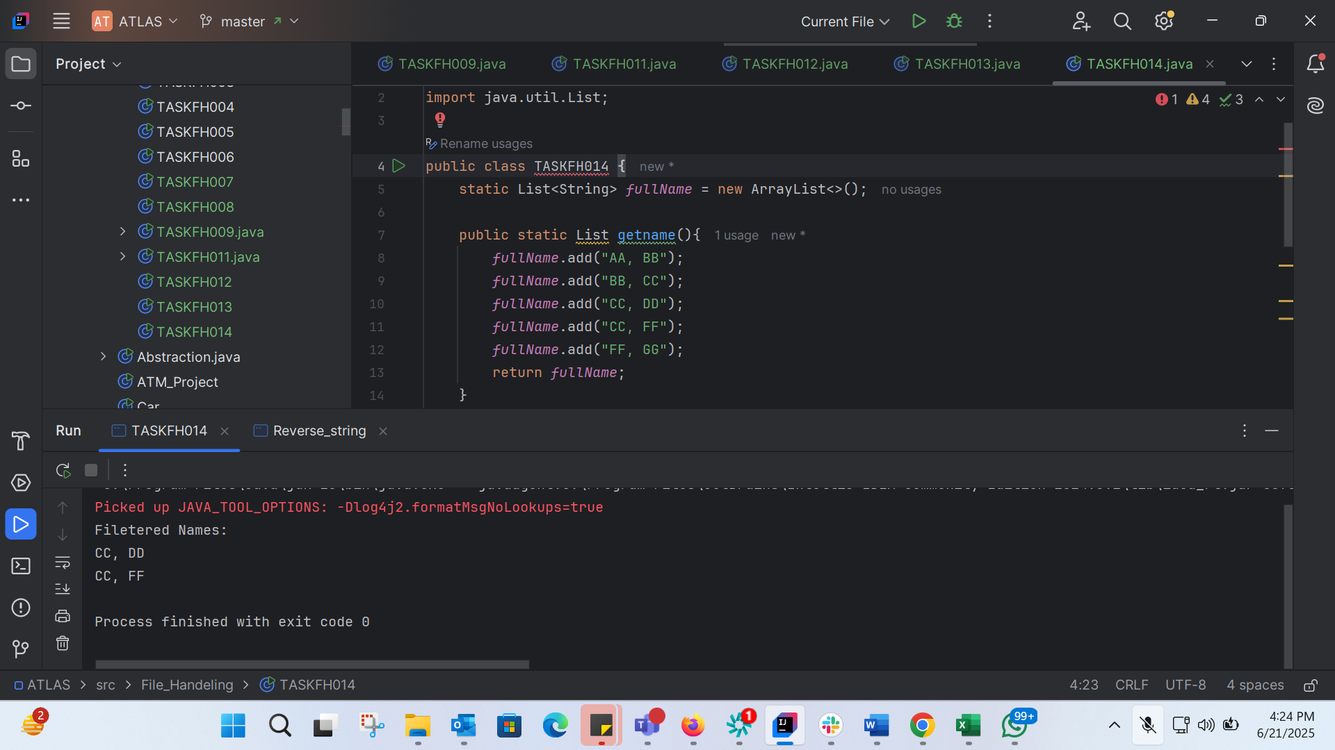
import java.util.ArrayList;
import java.util.List;
public class TASKFH014 {
static List<String> fullName = new ArrayList<>();
public static List getname(){
fullName.add("AA, BB");
fullName.add("BB, CC");
fullName.add("CC, DD");
fullName.add("CC, FF");
fullName.add("FF, GG");
return fullName;
}
public static void main(String[] args) {
List<String> myNames = getname();
System.out.println("Filetered Names:");
myNames.stream()
.filter((p)->p.startsWith("CC"))
.map((p)->p.toUpperCase())
.sorted()
.forEach((p)-> System.out.println(p));
}
}

TASK 15:
package File_Handeling;
import java.util.ArrayList;
import java.util.List;
import java.util.stream.Collectors;
public class TASKFH015 {
public static void main(String[] args) {
List<Integer> numbers = new ArrayList<>();
numbers.add(1);
numbers.add(2);
numbers.add(3);
numbers.add(4);
numbers.add(5);
List<Integer> squares = numbers.stream()
.map(n -> n * n)
.collect(Collectors.toList());
System.out.println("Numbers: " + numbers);
System.out.println("Squares: " + squares);
}
}

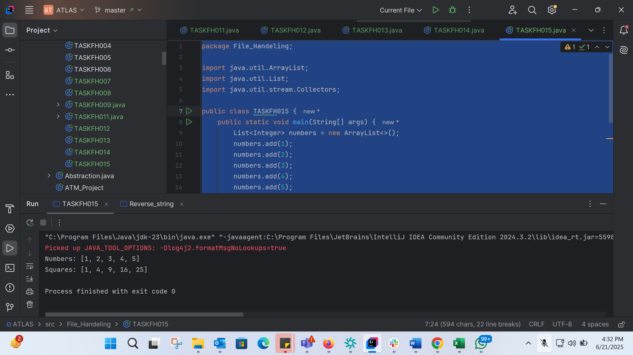
TASK 16: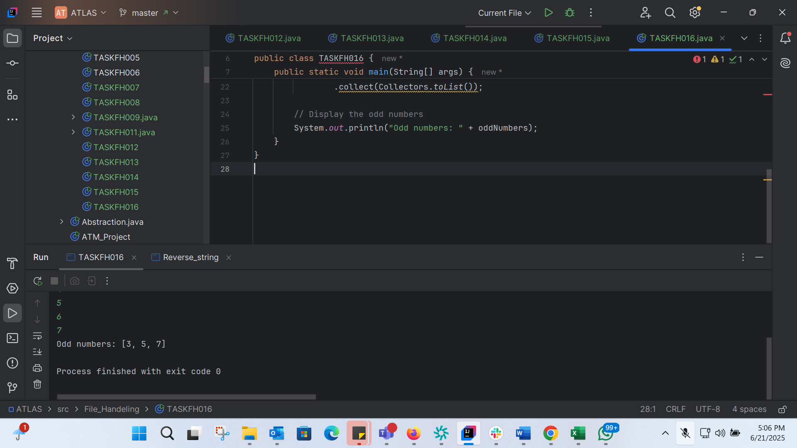
import java.util.ArrayList;
import java.util.List;
import java.util.Scanner;
import java.util.stream.Collectors;
public class TASKFH016 {
public static void main(String[] args) {
Scanner scanner = new Scanner(System.in);
List<Integer> numbers = new ArrayList<>();
System.out.print("Enter the number of elements: ");
int n = scanner.nextInt();
System.out.println("Enter " + n + " numbers:");
for (int i = 0; i < n; i++) {
numbers.add(scanner.nextInt());
}
// Filter out the odd numbers
List<Integer> oddNumbers = numbers.stream()
.filter(num -> num % 2 != 0)
.collect(Collectors.toList());
// Display the odd numbers
System.out.println("Odd numbers: " + oddNumbers);
}
}

TASK 17: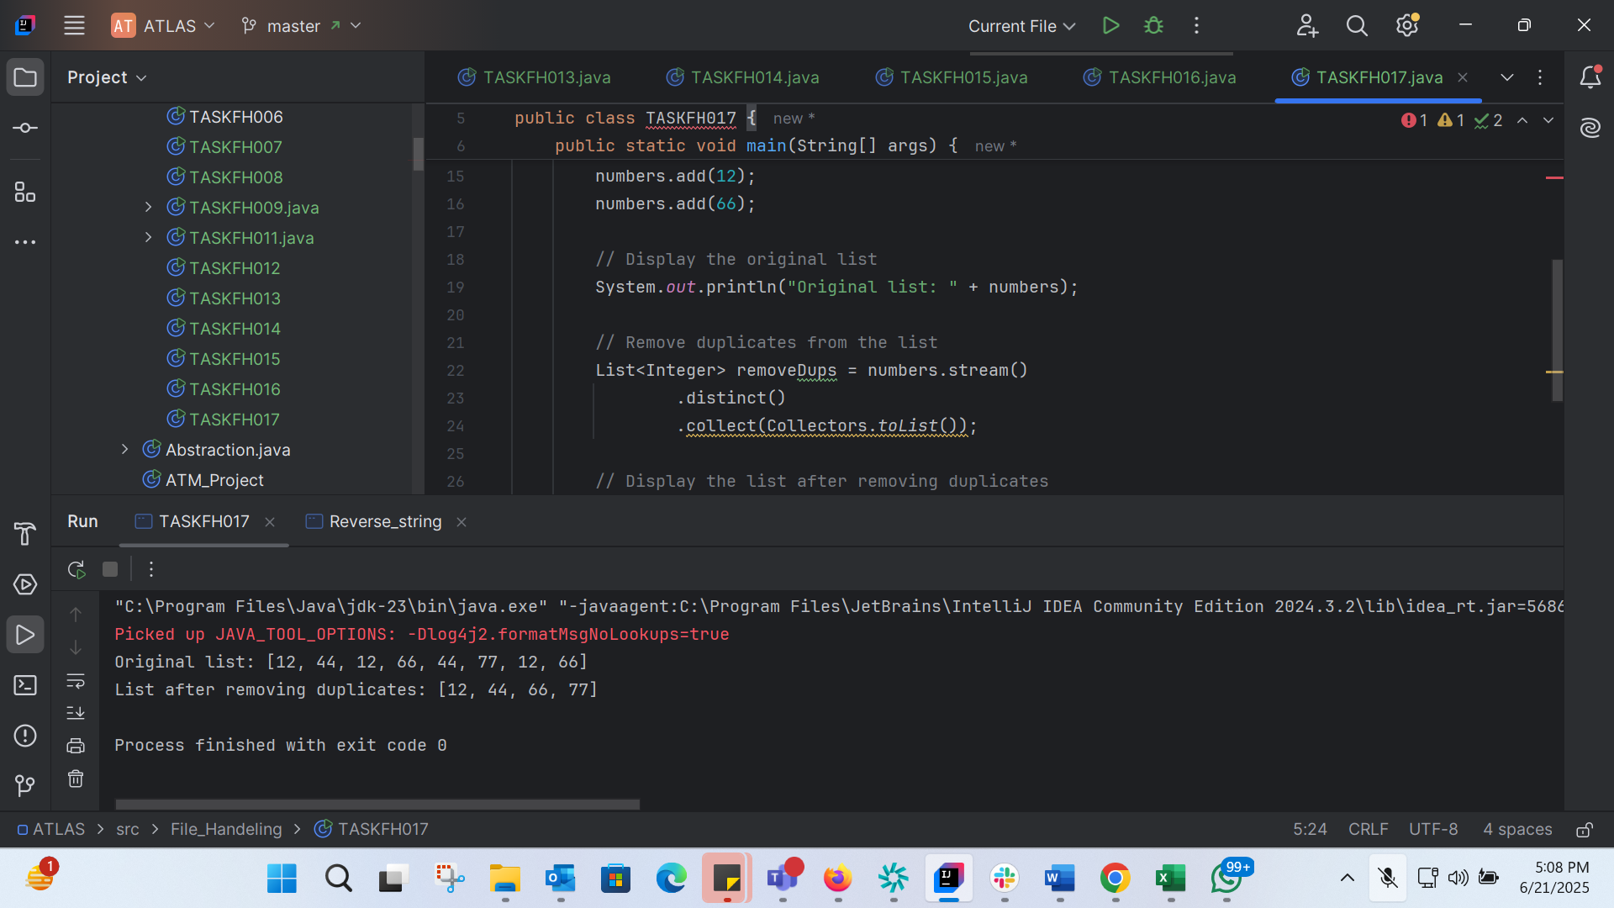
import java.util.ArrayList;
import java.util.List;
import java.util.stream.Collectors;
public class TASKFH017 {
public static void main(String[] args) {
// Create an ArrayList of integers
List<Integer> numbers = new ArrayList<>();
numbers.add(12);
numbers.add(44);
numbers.add(12);
numbers.add(66);
numbers.add(44);
numbers.add(77);
numbers.add(12);
numbers.add(66);
// Display the original list
System.out.println("Original list: " + numbers);
// Remove duplicates from the list
List<Integer> removeDups = numbers.stream()
.distinct()
.collect(Collectors.toList());
// Display the list after removing duplicates
System.out.println("List after removing duplicates: " + removeDups);
}
}

TASK 18: 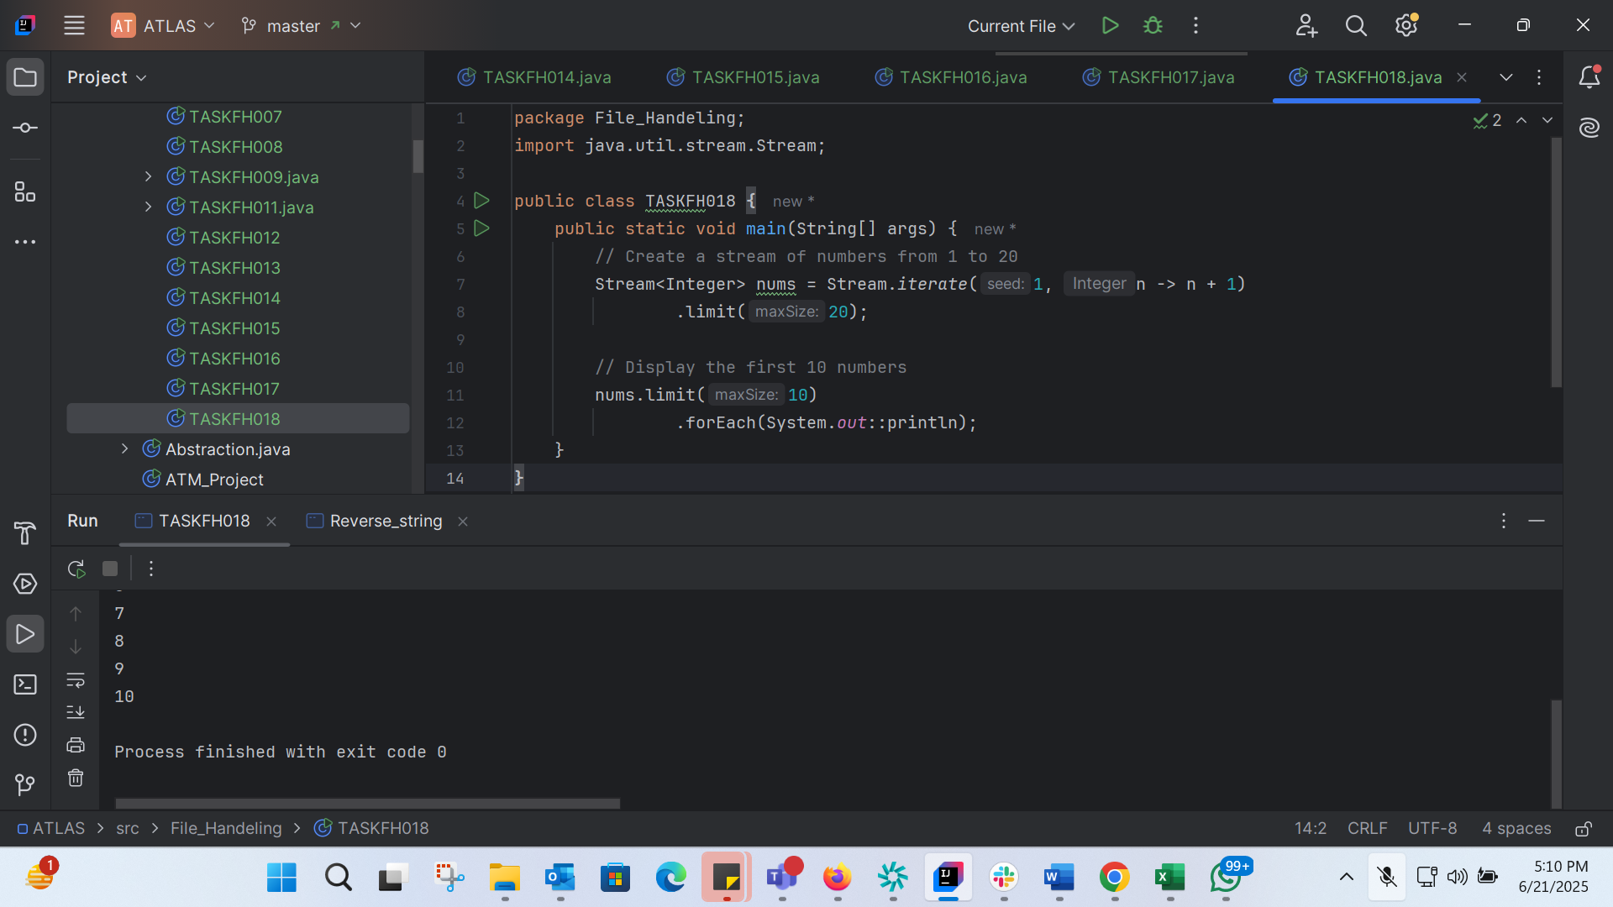
package File_Handeling;
import java.util.stream.Stream;
public class TASKFH018 {
public static void main(String[] args) {
// Create a stream of numbers from 1 to 20
Stream<Integer> nums = Stream.iterate(1, n -> n + 1)
.limit(20);
// Display the first 10 numbers
nums.limit(10)
.forEach(System.out::println);
}
}

TASK 19: 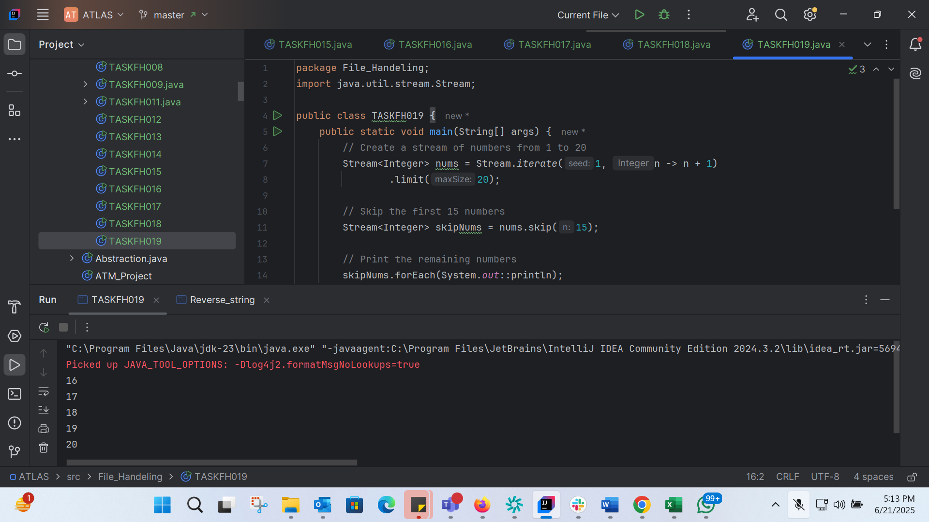
package File_Handeling;
import java.util.stream.Stream;
public class TASKFH019 {
public static void main(String[] args) {
// Create a stream of numbers from 1 to 20
Stream<Integer> nums = Stream.iterate(1, n -> n + 1)
.limit(20);
// Skip the first 15 numbers
Stream<Integer> skipNums = nums.skip(15);
// Print the remaining numbers
skipNums.forEach(System.out::println);
}
}

TASK 20: 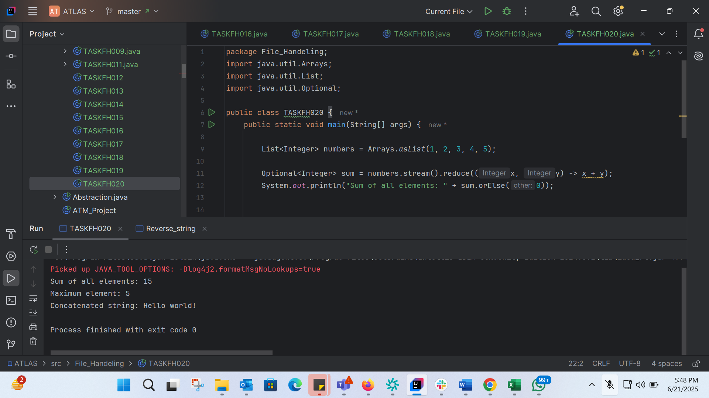
package File_Handeling;
import java.util.Arrays;
import java.util.List;
import java.util.Optional;
public class TASKFH020 {
public static void main(String[] args) {
List<Integer> numbers = Arrays.asList(1, 2, 3, 4, 5);
Optional<Integer> sum = numbers.stream().reduce((x, y) -> x + y);
System.out.println("Sum of all elements: " + sum.orElse(0));
Optional<Integer> max = numbers.stream().reduce(Integer::max);
System.out.println("Maximum element: " + max.orElse(0));
List<String> strings = Arrays.asList("Hello", " ", "world", "!");
Optional<String> concatenatedString = strings.stream().reduce((x, y) -> x + y);
System.out.println("Concatenated string: " + concatenatedString.orElse(""));
}
}

